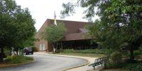
St. Vincent de Paul Food Pantry

Located in St. Francis de Sales Ministry Center
135 S. Buesching Road, Lake Zurich, IL
How It Works:
- The Pantry is open every Thursday from 5:00 – 7:00 p.m.
- New clients (Lake County residents only) should bring a photo ID and two forms of ID for proof of residency (e.g., a utility bill, phone bill, driver’s license, etc.) with them on their first visit. We will register you in our system and provide you a temporary ID card.
- You will receive a pantry card that you will use each time you come to the pantry.
What’s Available:
- Fresh fruit, vegetables, bread, and meat
- Breakfast cereal, peanut butter, rice, pasta, crackers,
- Canned fruits, vegetables, soups, condiments
- Milk and eggs
Special Notes:
- If more than one family lives at the same address, both families can get their own pantry card and receive food.
- If you are not available on Thursday nights, arrangements can be made so that you can receive food.
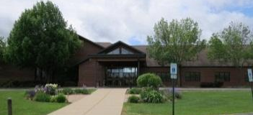
Hope Collective Food Pantry

Echo Lake/Miller Road, Lake Zurich
How It Works:
- The food pantry is open every Saturday from 9:00 a.m. – 11:00 p.m.
- Please bring a photo ID.
What’s Available?
- Non-perishables, produce, meat, and non-food items.

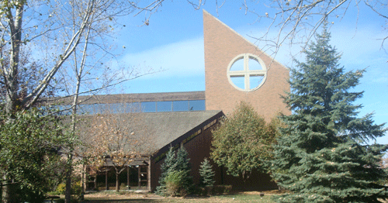
Emmaus House

St. Francis de Sales Church Basement
135 S. Buesching Rd., St Francis de Sales Church
How It Works:
- The Harvest Room at Emmaus House is open every Sunday from 4:00 p.m. – 5:00 p.m.

